Time Series Forecasting of Reportable Infectious Disease Trends in Public School Settings Across Antipolo City (2016 – 2025)

Rafael C. Bisnar, Neil Sean D. Mejia, Miguel Pallasigui, and Christian Louie C. Raoet
Department of Computer Science, Technological Institute of the Philippines, Quezon City
CS-307: Thesis 1
Ms. Janice Capule
November 10, 2026

Time Series Forecasting of Reportable Infectious Disease Trends in Public School Settings Across Antipolo City (2016–2026)
Infectious diseases remain one of the most persistent threats to public health in the Philippines, particularly in rapidly urbanizing areas where population growth outpaces the development of basic health and sanitation infrastructure. Under Republic Act No. 11332, health authorities are mandated to monitor and respond to notifiable diseases such as dengue, leptospirosis, and measles in order to detect outbreaks early and limit their spread. Despite this legal framework, cities across the CALABARZON region continue to report recurring surges in these diseases, often linked to seasonal weather patterns, poor drainage, and gaps in community immunization coverage.
Antipolo City, now the most populous city in CALABARZON with a population exceeding 900,000 (Philippine Statistics Authority, 2025), exemplifies this challenge. Rapid urban expansion has converted much of its natural vegetation and open land into dense built-up residential settlements, frequently straining the city’s infrastructure and leaving areas without sufficient sanitation or flood control systems (Qusiquisan, 2024; Sobremonte-Maglipon et al., 2024). These conditions have made the city a consistent regional hotspot for both vector-borne and waterborne illness, as reflected in dengue caseloads that have outpaced neighboring municipalities (Hedreyda, 2022) and leptospirosis outbreaks tied directly to flooding during the rainy season (Patriciaquiapo, 2026). Measles, meanwhile, has re-emerged as a serious concern following pandemic-era disruptions to routine childhood vaccination, contributing to a steep national rise in cases (Navalta, 2023) and prompting targeted immunization responses in Antipolo and neighboring high-risk towns (Mallari, 2026).
Because these outbreaks tend to follow recognizable seasonal and cyclical patterns rather than occurring at random, they are well-suited to time series forecasting methods. In particular, the Seasonal Autoregressive Integrated Moving Average (SARIMA) model has been shown to be effective in capturing the seasonal and climate-driven behavior of tropical infectious diseases (Warnasekara et al., 2022), including dengue (Olana et al., 2025) and measles (Parreño, 2025) trends in the Philippine setting. This study applies SARIMA and NNAR modeling to ten years (2016–2025) of monthly reported dengue, leptospirosis, and measles cases in Antipolo City, spanning the pre-pandemic, pandemic, and post-pandemic periods, in order to move beyond retrospective case reporting toward a data-driven, predictive approach that can support local health authorities in early outbreak preparedness.

Background of the Study
Reportable infectious diseases are illnesses that must be reported to health authorities, as required by Republic Act No. 11332, also called the Mandatory Reporting of Notifiable Diseases and Health Events of Public Health Concern Act. This law requires the Department of Health to monitor and respond to reportable diseases, including new or returning infectious diseases and outbreaks, to help identify and treat them early. This study targets the Dengue, Leptospirosis, and Measles affecting children of school age in Antipolo City that are monitored by the Department of Health's surveillance system. Although they spread in different ways, they all tend to increase quickly in areas with problems such as crowded living conditions, poor drainage, and weak community health systems.
Antipolo City is the most populous in CALABARZON and the seventh-largest in the Philippines. According to the 2024 Census of Population, the city now has a population of 913,712 (Philippine Statistics Authority, 2025). In the last few decades, many people have moved from Metro Manila to Antipolo. This caused the city to grow rapidly, with natural vegetation being converted into built-up neighborhoods and informal settlements (Qusiquisan, 2024; Sobremonte-Maglipon et al., 2024). But this rapid growth often outpaces the city's ability to build enough sanitation, drainage, and water systems. This lack of infrastructure leads to problems such as open water containers, inadequate flood control, and overcrowded living spaces. These conditions make it easier for infectious diseases to spread.
Dengue fever still presents a major public health challenge in the Philippines, with the CALABARZON region consistently reporting among the highest infection rates nationwide (Jaymalin, 2022). In 2022, the Department of Health (DOH) Center for Health Development CALABARZON reported that Antipolo City recorded the highest number of dengue cases in the region, with 601 cases documented by mid-July (Hedreyda, 2022). Notably, Antipolo's caseload represented nearly 46% of the 1,317 cases reported across Rizal province during the same period, showing its heightened vulnerability compared to adjacent towns (Hedreyda, 2022).
This aligns with recent Philippine research showing that population and environmental factors, including built-up areas and vegetation cover, are directly linked to where dengue hotspots persist within a city (Medina et al., 2025). Other research shows that in fast-growing cities, factors such as open water containers and poor garbage disposal make it easier for mosquitoes to breed and spread dengue (Olana et al., 2026).
Leptospirosis is a serious disease spread through water and is a big health risk in the Philippines, especially in cities that often flood. Health records show that Antipolo City is more at risk for leptospirosis than other nearby towns. Studies show that crowded communities in the Philippines often come into contact with floodwater that has Leptospira bacteria (Labana, 2026). Poor drainage, bad waste management, and heavy rain turn regular floods into major health problems (Interior et al., 2025).
Measles is a highly contagious disease that spreads through the air and is becoming a growing health problem in Antipolo City due to a recent nationwide rise in cases. Recent health reports say that when regular childhood vaccinations were disrupted during the COVID-19 pandemic, many Filipino children were left unprotected, leading to big gaps in the community's ability to fight measles (Cordero, 2024). As a result, the Department of Health (DOH) reported a 299% increase in measles cases in the Philippines from January to October 2023 compared with the previous year (Navalta, 2023). During this rise in cases, CALABARZON has remained a main hotspot. By May 2025, data from the Department of Health (DOH) showed that CALABARZON had 289 measles-rubella cases, making it the second most affected region in the Philippines after the National Capital Region (Sampang, 2025).
Seeing that Antipolo was at risk again during the 2025–2026 increase in cases, health authorities had to act quickly. To prevent another large outbreak, the Department of Health (DOH) and the Department of the Interior and Local Government (DILG) selected Antipolo City and three other high-risk towns in Rizal to conduct a special Measles-Rubella Supplemental Immunization Activity (MR SIA) in August 2026 (Mallari, 2026).
Antipolo City’s crowded neighborhoods and limited infrastructure make it vulnerable to extreme weather, such as heavy monsoon rains that cause floods, increase mosquito breeding, and raise the risk of leptospirosis. This results in infectious disease outbreaks in the city not being random, but rather following a regular, seasonal pattern. Notifiable diseases in the Philippines are strongly influenced by the Southwest and Northeast Monsoons: a recent Philippine case study found that dengue, leptospirosis, and other flood-associated diseases all had significantly higher case counts during monsoon weeks compared to non-monsoon weeks (Tan et al., 2025). Public health authorities need more than just records of past cases to protect the public; they need tools to predict when the next outbreak may occur.
To understand and predict these outbreaks, this study uses Time Series Analysis. This is a method that looks at past data to find patterns and predict what might happen next. The study uses both the Seasonal Autoregressive Integrated Moving Average (SARIMA) model and the Neural Network Autoregression (NNAR) model. Simple statistical tools often have trouble predicting diseases that increase during certain seasons, like the rainy season. SARIMA, however, is designed to handle these seasonal changes. Studies show that SARIMA is a very accurate tool for forecasting tropical diseases that are strongly affected by climate and the environment (Warnasekara et al., 2022).
Recent health studies in the Philippines confirm that SARIMA is highly effective for predicting local infectious diseases. For example, a study in Davao City used SARIMA to accurately forecast the annual surge of dengue cases every July and August (Servillon, 2024). On a wider scale, a nationwide study comparing forecasting tools found that while newer machine learning methods (like NNAR) had slightly lower error rates, SARIMA still provided a very strong and reliable baseline for predicting yearly dengue trends across all provinces (Olana et al., 2025). Furthermore, SARIMA has proven effective not just for mosquito-borne illnesses, but also for tracking complex airborne diseases like measles, even after the disruptions caused by the COVID-19 pandemic (Parreño, 2025).
By applying both SARIMA and NNAR to Antipolo City’s past health records, this research shifts the local government's approach from simply reacting to outbreaks to actively anticipating them. Accurate, data-driven forecasts will give the City Health Office valuable lead time to plan. With early warnings, health officials can prepare hospital beds, launch mosquito-control operations, and schedule targeted vaccination drives months before an outbreak peaks. Ultimately, using these predictive models will help reduce the severe impact of infectious diseases on the community.
To clearly see how these diseases change over time, a strong set of past data is needed. This study covers 10 years, from 2016 to 2025. This decade is important because it covers three main public health periods: the normal seasonal disease patterns before the pandemic (2016–2019), the big changes caused by COVID-19 lockdowns (2020–2022), and the sharp rise in cases after the pandemic when communities returned to normal (2023–2025).
Recent studies show that strict COVID-19 lockdowns reduced the spread of mosquito-borne diseases such as dengue worldwide (Castro et al., 2024). At the same time, the pandemic meant that many Filipino children missed their regular vaccines between 2020 and 2022, which left big gaps in community protection (World Health Organization, 2024). When lockdowns ended and people started moving around again, these problems led to a strong comeback of both dengue and measles in the Philippines starting in 2023 (World Health Organization, 2023). By looking at the full ten-year period, the SARIMA and NNAR models can learn how these diseases behave not just during usual seasonal changes but also during periods of major social change. Having this wide range of past information is important for helping statistical forecasting tools make better and more accurate predictions.
Beyond regional disease trends, the condition of Antipolo’s public schools adds to this risk. A government study on Philippine school infrastructure found that classroom crowding remains a serious problem in key regions, including CALABARZON, where student-to-classroom ratios continue to exceed the national target, and where many schools also lack adequate water, sanitation, and hygiene facilities (Navarro, 2022). These conditions make it easier for infectious diseases to spread once inside a school. This risk is not only theoretical: in 2022, health authorities investigated an outbreak of hand, foot, and mouth disease in a public school in Pangasinan, where several students tested positive for the same virus after close contact with an infected classmate (Victori et al., 2023). This case shows that Philippine schools can be an active site of disease transmission, not just a setting shaped by outside conditions. Taken together, these studies support the idea that Antipolo’s crowded and rapidly urbanizing environment, which directly impacts public infrastructure like schools (Qusiquisan, 2024), may be another important factor behind the city’s ongoing dengue, leptospirosis, and measles cases.
How well these risks are managed depends heavily on whether local government units (LGUs) have digital tools that turn health data into useful, real-time information. In the Philippines, disease reporting still mostly relies on manual data collection through the Philippine Integrated Disease Surveillance and Response (PIDSR) system, and interactive dashboards that can help LGU health offices forecast disease trends are still rare. Some recent government-backed projects are starting to address this gap. The Philippine Council for Health Research and Development is currently testing HealthPH, a dashboard that shows disease trends on a map using data from social media, meant for use by local governments and health offices (Philippine Council for Health Research and Development [PCHRD], 2025). In a related study, a web-based Barangay Management System created for local governance in Negros Oriental was shown to improve how barangay officials deliver services and manage information (Dandan et al., 2026). Together, these studies show that while there is growing interest in digital tools for LGUs, working dashboards built specifically for public health forecasting are still uncommon in the Philippines. This is the gap that the proposed dashboard for Antipolo City aims to fill.
Since this study will also produce a working, web-based dashboard, it is important to look not only at how accurate its forecasts are, but also at how good the system itself is. The ISO/IEC 25010:2011 standard, known as SQuaRE, is a widely accepted framework used to evaluate software quality. It looks at factors such as whether the system does what it is supposed to do, how well it performs, how easy it is to use, how reliable it is, and how easy it is to maintain. This standard has already been used to evaluate government and public-sector information systems in the Philippines. One recent study developed and evaluated an information system for digital governance in a Philippine state university using ISO/IEC 25010, and IT experts rated the system as excellent in terms of overall product quality (Lagman et al., 2024). In a similar study, the same standard was used to evaluate a Barangay Management System in the Philippines. Users and IT experts rated the system well in terms of functionality, reliability, and performance, though they noted that regular maintenance and training were still needed (Dandan et al., 2026). These studies show that ISO/IEC 25010 is a suitable and commonly used framework for evaluating government-related digital systems in the Philippines, including the dashboard that this study will develop.

Project Objectives
This study aims to analyze the temporal dynamics in the number of Dengue, Leptospirosis, and Measles affecting children of school age in Antipolo City, from January 2016 to December 2025. Furthermore, the study will create a combined SARIMA-NNAR forecasting model that is embedded in an online epidemiologic dashboard.
Specifically, the study aims to:
- To develop a hybrid SARIMA-NNAR forecasting model, using 10 years (2016–2025) of historical Antipolo City disease data, that identifies seasonal patterns and predicts Dengue, Leptospirosis, and Measles case spikes up to 12 months ahead, validated against real-world case data.
- To build an interactive, web-based dashboard that visually presents these forecasts, enabling the City Health Office to shift from reactive to proactive planning.
- To provide advanced and disease-specific 12-month forecasts through the dashboard that support timely resource and supply mobilization ahead of anticipated case peaks.

Significance of the Study
The findings of this study can be used to produce data-driven seasonal disease forecasts, providing health administrators with the information needed to prevent outbreaks from spreading within schools. Furthermore, this study is conducted to benefit the following:
For the local government of Antipolo City and its Health Office, the system provides seasonal disease forecasts that can anticipate seasonal surges of Dengue, Leptospirosis, and Measles affecting the city's pediatric demographic based on historical disease data. The time series analysis of the seasonal disease trends can be used to produce forecasts and support the local government in planning, making data-driven decisions, providing interventions, and coordinating responses with the health authorities.
For school administrators in Antipolo City, the system can provide advance forecasts of possible surges of Dengue, Leptospirosis, and Measles affecting the city's pediatric demographic, which can be used to coordinate with health authorities and implement preparations.
For the students and teachers in Antipolo City public schools, the system’s seasonal disease forecast can reduce their risk of exposure to these diseases by giving the school administrators and the health authorities the time and information needed to implement preventive measures for the school ahead of the predicted disease surges.
For future researchers, this study can serve as a foundational reference for infectious disease forecasting in the Philippines. The methodology and dataset used can be extended to cover other reportable infectious diseases and applied to other cities in the Philippines. This study also demonstrates an application of SARIMA modeling in a public health setting.

Scope and Delimitation
Scope
The scope of the predictive model is strictly limited to Dengue, Leptospirosis, and Measles disease cases among the school-aged demographic (5-19 years old) in Antipolo City. The primary analytical scope of this study is the application of a hybrid SARIMA-NNAR forecasting approach, in which SARIMA models the linear and seasonal components of each disease's case trajectory, while NNAR captures the nonlinear structure in the residuals. Furthermore, the system will not aggregate these diseases into a single forecast; instead, five (5) distinct, disease-specific SARIMA and NNAR models will be trained to ensure mathematical accuracy for each unique seasonal pattern. It will look at the total number of new cases for each disease every month. SARIMA will be used to capture the linear and seasonal patterns of the diseases, while NNAR will be applied to model the complex, nonlinear epidemic trajectories. The data come from official records collected over ten years (January 2016 to December 2025), provided by the Antipolo City Health Office (CHO) and/or the Department of Health (DOH) through the Philippine Integrated Disease Surveillance and Response (PIDSR) system. This period includes the period before the pandemic, the COVID-19 lockdowns, and the period after the pandemic, when disease cases changed again.
For the technical part, this study uses a quantitative time-series design, examining past data. All analysis is done using Python 3.11. The study uses the pandas library to prepare the data and the statsmodels library to build and improve the SARIMA models for each disease. The final result will be an interactive online dashboard made with Plotly Dash. This dashboard will show past disease trends and predict the number of new cases for the next year, helping local health officials plan for the future.
Delimitation
To set clear limits for the study and ensure it is accurate and practical, the researchers have defined specific boundaries. First, even though the Philippine Integrated Disease Surveillance and Response (PIDSR) system tracks many health problems, this study does not include other diseases like Influenza-Like Illness (ILI), Tuberculosis, Hand, Foot, and Mouth Disease (HFMD), and COVID-19. These diseases were excluded because their patterns are not mainly affected by regular seasonal weather, which is important for SARIMA forecasting.
Both the SARIMA and NNAR models will be applied as univariate time-series analyses, which means it only looks at past case numbers to predict future cases. It does not use external weather data, such as rainfall or temperature, as additional factors. Instead, it depends on the model to find patterns in the disease data itself. The study is delimited to predicting future case numbers; it will not explain the underlying biological, environmental, or social causes of the outbreaks.
There are some limits to the data used in this study. The accuracy depends on the PIDSR’s passive reporting system. The model assumes that hospital and clinic records reflect the true trend for the whole city, but that mild or unreported cases are not included. Also, the data set includes the raw aggregated case volumes, whether they were suspected or confirmed in the laboratory, and does not adjust for changes in population size over the ten years. Because the model only uses past case data, it cannot separate the effects of outside health actions, like mosquito fogging or vaccination campaigns, done by the local government. The study only uses total monthly case numbers. It does not involve checking individual patients or collecting personal medical records, so it follows the Data Privacy Act of 2012 (Republic Act No. 10173). The forecasts are for the whole city, not for smaller areas like barangays or schools, to avoid problems with months that have no reported cases in those places.
For the technical part, the online dashboard made by this study is only meant as a sample for academic use and to help plan early warning systems. It will not actually be set up, hosted on the internet, checked for security, or connected to the Antipolo City government’s systems that are not part of this research. Also, the 12-month forecast can only use patterns seen in past data. It cannot predict rare or unusual events, such as very strong typhoons that have not occurred in the last ten years.

CHAPTER 2
Theoretical Framework

Review of Related Literature
Spatial Distribution Analysis and Comparative Forecasting of Dengue Resurgence in the Philippines (2025–2027): A Nationwide Study (Olana et al., 2025)
Olana et al. (2025) compared SARIMA against neural network autoregression (NNAR), random forest, LSTM, TBATS, and Prophet models using eight years of monthly nationwide dengue case data in the Philippines. This approach addresses the limitations of relying on a single forecasting method for a disease with well-documented national seasonality by benchmarking SARIMA against five alternative model types. The study found that dengue cases displayed regular seasonal epidemics peaking between July and September each year, consistent with the country's wet season, though NNAR ultimately outperformed SARIMA and the other models in forecast accuracy. This establishes a validated national-level seasonal benchmark for a tropical, vector-borne infectious disease within the Philippine context. The authors state that these findings should be used directly to strengthen national surveillance, prevention, and control efforts against dengue.

Long-Term Trend Analysis of Tuberculosis Cases in the Philippines from 2016 to 2023 (Parreño, 2026)
Parreño (2026) analyzed long-term tuberculosis trends across the Philippines over an eight-year period using data obtained through the Department of Health's eFOI portal. This approach addresses the limitations of relying on visual trend inspection alone by fitting a seasonal ARIMA(0,1,2)(0,1,1) model and applying the Mann-Kendall test to confirm statistical significance. The study found a statistically significant upward trend with seasonal peaks consistently occurring in March, forecasting continued March surges through 2025. This provides a national-level, statistically validated seasonal benchmark for tuberculosis directly comparable to the present study's geographic and disease focus. The author states that these forecasted March surges highlight the need to intensify active case-finding specifically in the January–March window and to allocate health resources adaptively around this pattern.
Another Measles Outbreak in the Philippines? The Essentiality of a Successful Vaccination Program and Public Cooperation (Cordero, 2024)
Cordero (2024) reviewed the resurgence of measles cases in the Philippines following the 2019 national outbreak, comparing incidence data from January–October 2023 against the same period in 2021. This approach addresses the limitations of treating the pandemic's effect on vaccine-preventable disease as a single uniform event by tracing a specific, delayed secondary spike years after the initial COVID-19 disruption. The review found a nearly 300% increase in measles cases, attributed primarily to pandemic-related disruptions in routine childhood immunization services and continued vaccine hesitancy following the earlier Dengvaxia controversy. This provides recent national context for measles' continued relevance as a target disease and illustrates how COVID-era disruption effects can surface with a multi-year delay. The author emphasizes that routine immunization services need to be strengthened specifically to prevent further outbreaks of this kind.
Forecasting Measles Incidence in the Philippines: A Comparative Analysis of SARIMA, Holt-Winters, ESN, and NNAR Models (Parreño, 2025)
Parreño (2025) compared SARIMA, Holt-Winters, Echo State Network (ESN), and NNAR models on weekly Philippine measles incidence data spanning January 2017 to October 2023, using Predictive Mean Matching (PMM) to address missing-data gaps. This approach addresses the limitations of missing and pandemic-distorted surveillance data by applying a validated imputation method before model comparison. The study found that NNAR produced the lowest prediction errors across RMSE, MAPE, and MAE, and was judged the most effective model overall, though SARIMA still adequately captured the series' seasonal structure despite pandemic-era outliers. This demonstrates both SARIMA's continued adequacy for seasonal Philippine disease data and a validated missing-data handling method directly applicable to the present study's own administrative dataset.
Epidemiology Forecasting Analysis of Dengue Cases with Seasonal Autoregressive Integrated Moving Average in Davao City, Philippines (Plaza et al., 2024)
Plaza et al. (2024) utilized the seasonal autoregressive integrated moving average (SARIMA) model to predict dengue cases across the administrative districts of Davao City for the years 2020-2025, using historical data from 2013 to 2019. This approach addresses the lack of model-based solutions for forecasting and detecting the spread of dengue in the country by identifying a combined forecast model that yielded the lowest root mean square error (RMSE). The study found a consistent monthly variation with dengue cases peaking during July and August. This establishes a validated, city-level seasonal benchmark for applying SARIMA to predict vector-borne diseases in the Philippines. The authors emphasize that this prediction model can serve as an early alert and monitoring system to help mitigate future outbreaks.
Dengue Incidence Forecasting Model in Magalang, Pampanga Using Time Series Analysis (Mendoza, 2024)
Mendoza (2024) developed an Auto-Regressive Integrated Moving Average (ARIMA) model to predict dengue incidence in Magalang, Pampanga, utilizing weekly dengue and climatological data from 2016 to 2019. It is an approach that satisfies the requirements of accurate predictions in the local area by automatically selecting a non-seasonal ARIMA(0,1,6) model as the climate variable that best explains the rainfall sum of 7 variables. The study revealed that quarterly forecasting is best for predicting 2020 dengue incidences as compared to semi-annual and annual forecasting, which was confirmed with ANOVA and Diebold-Mariano tests. This serves as a robust methodological benchmark for assessing time series models at the municipal level, which is the focus of this study, and directly aids the analysis of local patterns of infectious diseases. Model validation is extremely important to minimize risks due to error and help local authorities allocate budgets and prepare more relevant policies on disease management, states the author.
Exploring Morbidity Cases in a Municipality in Zamboanga del Norte, Philippines: A Time Series Analysis and Forecasting Study (Patayon et al., 2023)
Patayon et al. (2023) employed the Prophet algorithm to forecast future trends and seasonal patterns for various morbidity cases, including pneumonia and upper respiratory tract infections, in Tampilisan, Zamboanga del Norte, using data from 2017 to 2023. This method responds to the difficulties of dealing with nonlinear data, missing values, and the enormous effect of the COVID-19 pandemic on non-COVID morbidity cases over the last two years of the recorded data between January 2020 and January 2022, which saw an unprecedented drop in cases due to the public’s hesitation to visit health facilities. For infectious diseases such as pneumonia, the study revealed that the Prophet model resulted in a high coefficient of determination (R²) and a low root mean square error (RMSE). This provided a good example of how the modern approach to algorithmic forecasting can overcome data disruptions during a pandemic and is consistent with the goal of this study to examine disease trends over the pre-pandemic, pandemic, and post-pandemic era. The authors call for using these projections to create a full intervention plan and public health policies to prevent and control disease in the community.

Design Concept
This study will develop a forecasting method using ten years of monthly data for dengue, leptospirosis, and measles in Antipolo City. It then uses that past pattern to estimate what each illness may do in the coming year. This plan is meant to help the Antipolo City Health Office and the people in charge of schools act earlier. They can line up hospital bed needs, plan mosquito control steps, and set up vaccination efforts ahead of any rise in cases. The focus is on getting ready before an outbreak is already in progress.
A hybrid SARIMA-NNAR approach was chosen over relying on either model alone. SARIMA was chosen since earlier studies in the Philippines often reported it as a steady and easy-to-explain starting point. It fits patterns that change with the seasons, like dengue and its higher rates during the rainy months. It also matches measles patterns, even when COVID-19 disturbed regular reporting. However, SARIMA alone may not catch the harsher ups and downs in case numbers. Those irregular shifts can come from things such as lockdowns during the pandemic or sudden vaccination pushes. NNAR was added specifically to model these leftover, harder-to-predict patterns that remain in SARIMA's residuals, following the same logic used in other hybrid disease-forecasting studies that combine classical and machine-learning techniques to lower prediction error. Combining the two lets the system keep SARIMA's proven seasonal accuracy while still capturing the nonlinear disruptions unique to a ten-year dataset spanning the pre-, during-, and post-pandemic periods — something neither model could do as well on its own.

Figure 1 Input, Process, Output (IPO) Diagram depicts the design, development, and implementation of the hybrid SARIMA-NNAR forecasting system for the reportable infectious diseases dengue, leptospirosis, and measles, which impact the school-age population in Antipolo City.
Besides, the input phase also includes historical monthly data on dengue, leptospirosis, and measles in Antipolo City from January 2016 to December 2025. This input data is obtained through the PIDSR, specifically the Antipolo City Health Office (CHO) and/or the Department of Health (DOH), even for the periods that were before the pandemic, during, and after the pandemic.
The process phase consists of four parts in order to maintain a systematic workflow. The data preparation phase starts with the purification and coding of the initial case records, filling in blank monthly data, and identifying anomalies from the COVID-19 timeline. The analysis of the time series decomposes the records of each illness into their seasonal, trend, and residual components so that each series is analyzed for stationarity in the pre-, pandemic, and post-pandemic periods. The hybrid forecasting phase implies using the Seasonal Autoregressive Integrated Moving Average (SARIMA) model, which helps to describe linear and seasonal structures of the disease, and the Neural Network Autoregression (NNAR) model that is applied to residual values in order to grasp the nonlinear nature of the previously mentioned model. The model assessment phase involves using RMSE, MAE, and MAPE measures in order to verify the correctness of the forecasting and aims at achieving a MAPE less than 32.22%, which was set as a standard by Olana et al. (2025).
The output phase produces two key results, namely, the year-ahead forecast for each disease and the set of historical trend and seasonal decomposition visualizations. The results are made available through a web-based epidemiological dashboard created using Python (Dash, Pandas, and Statsmodels), allowing end-users, such as the Antipolo City Health Office and school administrators, to visualize disease trends in past years while at the same time making predictions of disease occurrences in the near future. Lastly, the evaluation phase evaluates the dashboard with respect to the ISO/IEC 25010:2011 (SQuaRE) standard, focusing on dimensions including functional suitability, performance efficiency, reliability, security, and usability.

Figure 1
The IPO (Input, Process, Output) Diagram
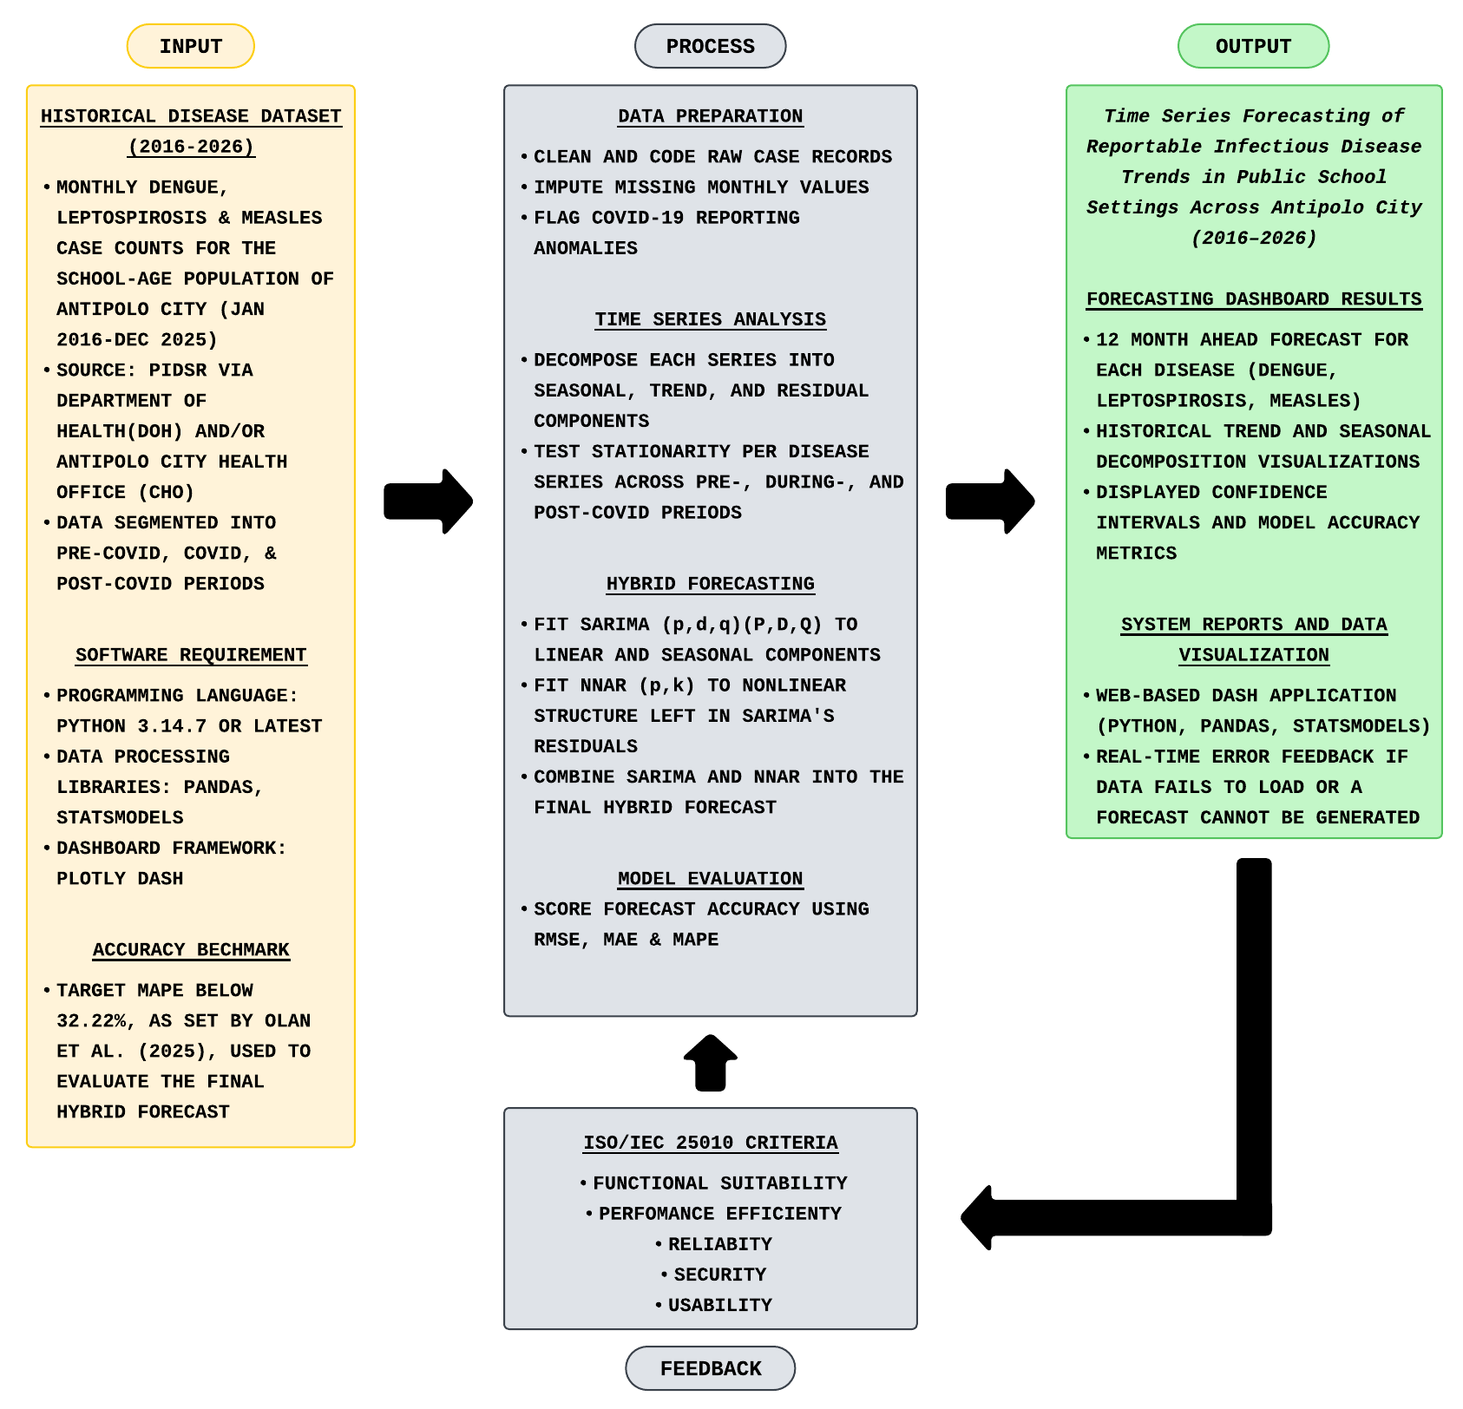

System Architecture
Proposed Hybrid SARIMA-NNAR Forecasting System
Figure 2 illustrates the system architecture of the proposed system, which includes the Presentation Tier, Logic Tier, and Data Tier, which all together form the foundation of the time series forecasting of reportable infectious diseases in public school settings across Antipolo City.
The Presentation Tier contains the graphical interface built with Plotly Dash where users can interact with the system through a web browser. Users can select a specific disease (dengue, leptospirosis, or measles) and a date range, then view results that include historical case trends, seasonal decomposition plots, and 12-month-ahead forecasts. The interface also displays model accuracy metrics and provides real-time alerts if data fails to load or a forecast cannot be generated.
The Logic Tier contains the Data Preparation Module, the Time Series Analysis Module, the Hybrid Forecasting Module, and the Model Evaluation Module, which processes all the logic in the system. The Data Preparation Module cleans the disease data records, imputes missing values, and flags COVID-related anomalies. The Time Series Analysis Module breaks each disease series into seasonal, trend, and residual components, then checks stationarity per series. The Hybrid Forecasting Module runs two models on this decomposed data: SARIMA models the linear and seasonal patterns in disease cases, and NNAR captures the nonlinear structure left in SARIMA's residuals. The Model Evaluation Module then computes RMSE, MAE, and MAPE on the combined forecast.

The Data Tier holds three stores. Historical Case Data Storage keeps the cleaned PIDSR/DOH disease records. Model Storage keeps the trained SARIMA and NNAR data. Forecast Output Storage keeps the generated 12-month predictions and decomposition results. The Logic Tier retrieves data from this tier and stores trained models and forecasts back into it.

Figure 2
The System Architecture of the Proposed System
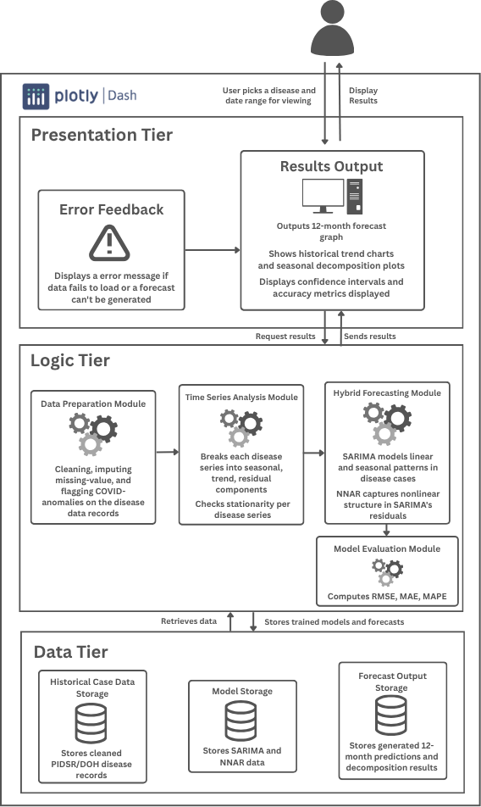
Seasonal Autoregressive Integrated Moving Average (SARIMA)
The Seasonal Autoregressive Integrated Moving Average (SARIMA) is an extension of the Autoregressive Integrated Moving Average (ARIMA) model where SARIMA adds a seasonal component that repeats throughout the time series at fixed intervals. The model uses the notation:
SARIMA (p,d,q) (P,D,Q)s
where p describes the autoregressive order, d for the non-seasonal differences, and q for the moving average order. While P, D, and Q describe the same three properties but for the seasonal component. The subscript s marks the length of the seasonal cycle, where setting it to 4 sets it to quarterly, 12 for monthly, and 52 for weekly. Fitting a SARIMA model follows a fixed sequence of steps, moving from data to a forecast.
In the SARIMA pipeline, stationarity testing is the first step where the Augmented Dickey-Fuller (ADF) test checks whether the raw data series has a stable mean and variance over time. If the series fails the stationarity test, differencing follows, where non-seasonal differencing subtracts each value from the one before it with the formula:
y'[t] = y[t] − y[t − 1]
where y'[t] is the differenced series at time t, y[t] is the original series at time t, and y[t−1] is the value of the series at the previous time step. This differencing process continues multiple times until stationarity is achieved.
Once the series is stationary, model identification uses the Autocorrelation Function (ACF) and Partial Autocorrelation Function (PACF) plots of the differenced series to select the remaining orders.
Parameter estimation then fits the chosen orders to the data using maximum likelihood estimation, which finds the coefficient values that best explain the observed case counts. Candidate models are compared using Akaike Information Criterion (AIC), and the combination of (p,d,q)(P,D,Q) that minimizes this score is selected for each disease.
Diagnostic checking examines the residuals of the fitted model. A Ljung-Box test confirms the residuals behave like white noise, meaning no further autocorrelation remains for the model to capture.
Figure 3
The System Architecture of SARIMA
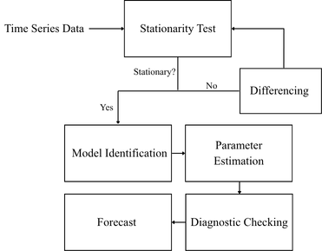
Neural Network Autoregression (NNAR)
The Neural Network Autoregression (NNAR) model uses lagged values of a time series as inputs to a neural network. This lets NNAR capture nonlinear patterns that SARIMA cannot represent on its own. The model considers only feed-forward networks with one hidden layer, using the notation:
NNAR (p, k)
where p is the number of lagged values used as input, and k is the number of nodes in the hidden layer.
Fitting an NNAR model has three layers which are the input layer, hidden layer, and output layer, which follow a fixed sequence of steps, where lagged input selection is the first step. In the input layer, the model takes the previous p values of the series as its input set to train and learn from.
After taking the previous p values, the hidden layer then processes these inputs, where each lagged value is combined through weighted connections into each hidden node, producing an output value for every node in the layer.
These hidden node outputs are then used by the output layer, which combines them into a single forecasted value: the network's prediction for the residual left over from the SARIMA model at time t, denoted e[t]. Once e[t] is predicted, it is used as a new input to predict e[t+1], and this process iterates for each subsequent step. The final forecast for each disease combines SARIMA's linear prediction with NNAR's predicted residual, producing the hybrid SARIMA-NNAR output.

Figure 4
The System Architecture of NNAR
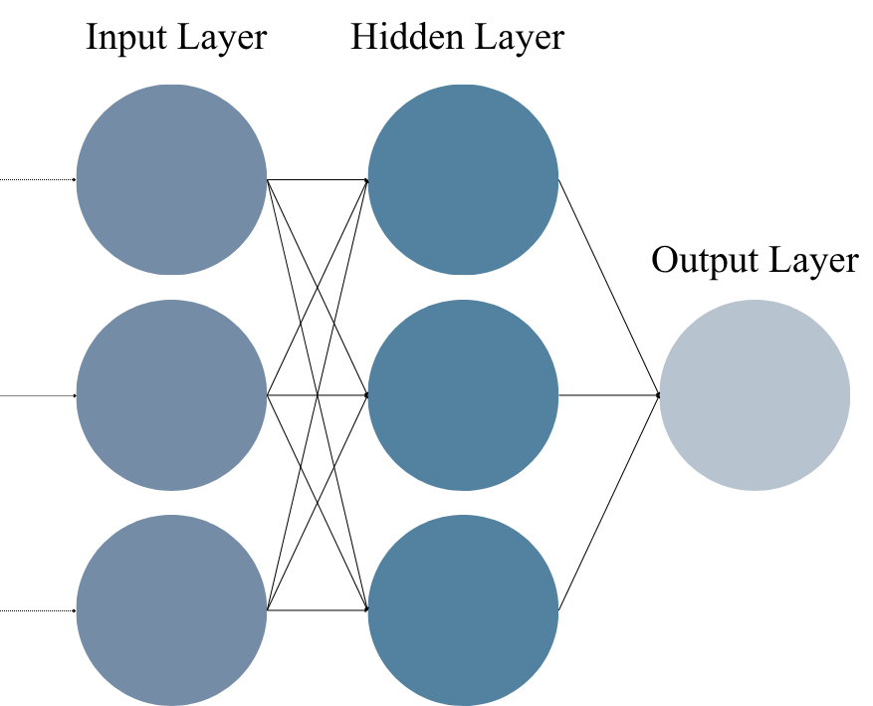

Flowcharts
Figure 5
Main flow of the System
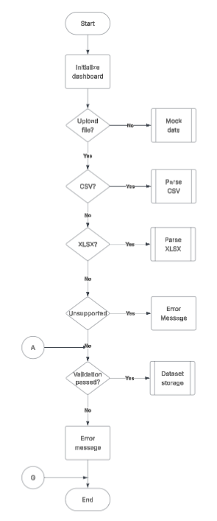
Figure 6

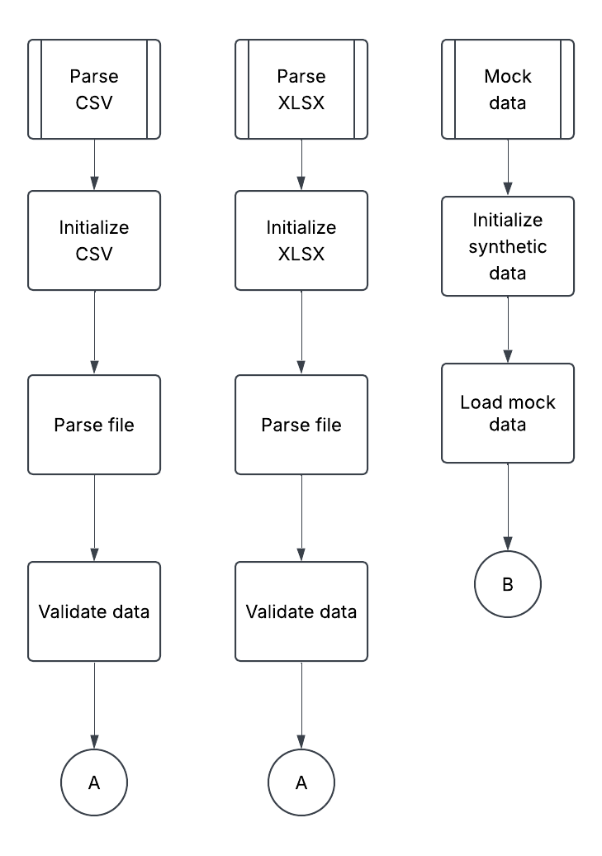
Sub-Modules of the Main System

Figure 7

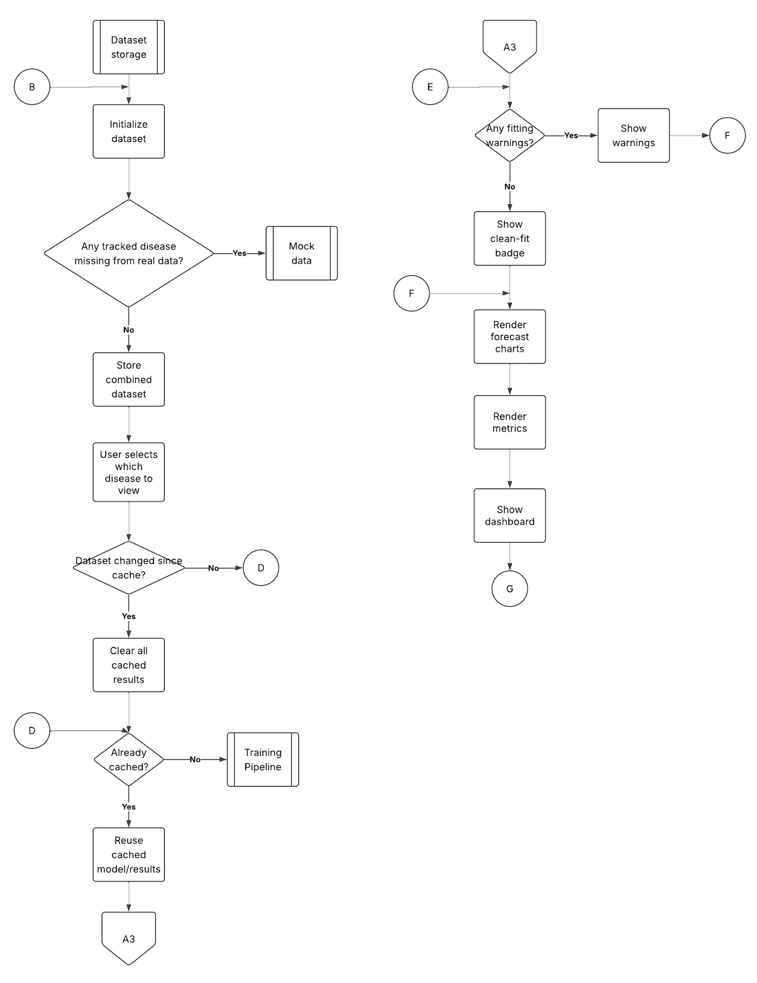
Data Storage Sub-Module of the Main System

Figure 8

Training Pipeline Sub-Module of the Data Storage

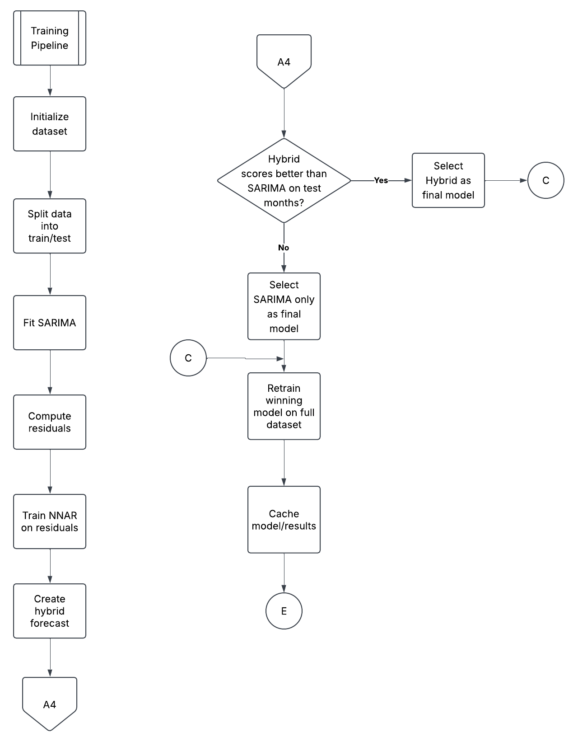

Comparative Analysis
Table 1
Time-Series Model Algorithms
Tools and Technologies, Computing processes, systems and theory used | Strength/s (uniqueness and novelty) | Opportunities  (areas for improvement/possible enhancement/innovation/adaptation of technology/computing theory) | Title and Author/s
SARIMA | - Explicitly separates non-seasonal and seasonal structure through coefficients  - Widely used in disease-forecasting literature | - Linear structure cannot capture nonlinear residual patterns on its own (Needs a Neural Network Model Algorithm) | Warnasekara J, Agampodi S, NR A (2022) SARIMA and ARDL models for predicting leptospirosis in Anuradhapura district Sri Lanka. PLOS ONE 17(10): e0275447. https://doi.org/10.1371/journal.pone.0275447
ARIMA | - Simple  - Works well on short series without strong seasonality. | - Base model does not capture the seasonal component to handle recurring cyclical patterns | Ab Rashid M, Ahmad Zaki R, Wan Mahiyuddin W, et al. (September 04, 2023) Forecasting New Tuberculosis Cases in Malaysia: A Time-Series Study Using the Autoregressive Integrated Moving Average (ARIMA) Model. Cureus 15(9): e44676. doi:10.7759/cureus.44676
Prophet | - Handles missing data and irregular seasonality well | - Holiday-effect assumptions are not tuned to climate-driven cycles, limiting fit for disease seasonality | Arslan, S. (2022). A hybrid forecasting model using LSTM and Prophet for energy consumption with decomposition of time series data. PeerJ Computer Science, 8, e1001.
TBATS | - Can model multiple overlapping seasonal cycles at once | - Multiple seasonal terms add unnecessary computational overhead | Olana, K. O. A., Poprom, N., Siewchaisakul, P., Punyapornwithaya, V., & Thongprachum, A. (2025). Spatial Distribution Analysis and Comparative Forecasting of Dengue Resurgence in the Philippines (2025–2027): A Nationwide Study. Transboundary and Emerging Diseases, 2025(1), 7480710.

Table 2
Machine Learning Model Algorithms
Tools and Technologies, Computing processes, systems and theory used | Strength/s (uniqueness and novelty) | Opportunities  (areas for improvement/possible enhancement/innovation/adaptation of technology/computing theory) | Title and Author/s
NNAR | - Offers less complexity  - Easier interpretability and better prediction than a standard ANN as a nonlinear autoregressive model | - The base model benefits from pairing with a linear seasonal model. | Olana, K. O. A., Poprom, N., Siewchaisakul, P., Punyapornwithaya, V., & Thongprachum, A. (2025). Spatial distribution analysis and comparative forecasting of dengue resurgence in the Philippines (2025–2027): A nationwide study. Transboundary and Emerging Diseases. https://doi.org/10.1155/tbed/7480710
LSTM (Long Short-Term Memory) | - Captures long-term dependencies well  - Performs on large sequential datasets | - Underperforms on smaller series without data augmentation or transfer learning | Ligue, K. D., & Ligue, K. J. (2022). Deep Learning Approach to Forecasting Dengue Cases in Davao City Using Long Short-term Memory (LSTM). Philippine Journal of Science, 151(3). https://doi.org/10.56899/151.03.01
SVM (Support Vector Machine) | - Combines classification and regression strengths for spatial-temporal dengue prediction using climate and lagged data | - Sensitive to hyperparameter choice | Meileni, H., Ermatita, Abdiansah, & Husni, N. L. (2025). Predicting dengue fever outbreaks through Support Vector Machine: The role of climate variables and time-lagged data. Journal of Advances in Information Technology, 16(6). https://www.jait.us/show-255-1709-1.html
Random Forest | - Handles nonlinear relationships without requiring stationarity  - Widely used in disease-forecasting literature | - Underperforms when compared to the LSTM model  - Does not natively exploit sequential/lag structure without manual configuration | Warnasekara, J., Agampodi, S., & Abeynayake, N. R. (2022). SARIMA and ARDL models for predicting leptospirosis in Anuradhapura district, Sri Lanka. PLOS ONE, 17(10), e0275447. https://doi.org/10.1371/journal.pone.0275447

Table 3
Definition of Terms
Term | Definition
Autocorrelation | The statistical property this study relies on to justify forecasting, the assumption that a disease's case counts in earlier months remain related to counts in later months.
ARIMA | The base time-series model this study builds on before adding seasonal terms, used to establish whether disease incidence retains an autocorrelative structure across the 2015–2025 dataset.
City Health Office | The Antipolo City government body identified in this study's stakeholder analysis as holding legitimacy and resource-allocation authority over disease surveillance response.
PIDSR | The government health information reporting structure from which this study’s ten-year dataset of monthly dengue, leptospirosis, and measles case counts in Antipolo City is obtained.
Decomposition | The preprocessing step applied in this study to separate each disease's raw incidence series into trend, seasonal, and residual components before SARIMA modeling.
Early Warning System | The practical output this study aims to produce a SARIMA-based tool that gives DepEd and the City Health Office month-ahead notice of expected incidence peaks.
Environment | The second element of the Epidemiological Triad as used in this study, referring to classroom proximity, ventilation, and seasonal/climatic conditions in Antipolo City.
Forecast | A prediction of future cases based on past data and can be used to give early information for the end users.
NNAR | A machine-learning algorithm employing a single-hidden-layer feed-forward network that is applied specifically to capture the nonlinear, harder-to-predict irregular shifts left over in the SARIMA model’s residuals.
Notifiable/Reportable Disease | The six specific disease categories this study tracks, each of which schools are required to report to DepEd and the City Health Office under existing surveillance mandates.
Passive Surveillance | The term this study uses to characterize Antipolo City's current disease reporting system, in contrast to the proactive, forecast-driven system this study proposes.
Plotly Dash | The specific software framework used in this study to build the interactive dashboard that displays trend visualizations, seasonal overlays, and outbreak alerts to school health officers.
Python 3.11 / pandas / statsmodels | The specific computational environment and libraries this study's SARIMA modeling and data-wrangling pipeline is built and constrained by.
Residual | The leftover component of a disease's decomposed time series in this study, checked during diagnostic testing to confirm the SARIMA model has captured all systematic patterns.
SARIMA | The foundational time-series model chosen for this study to specifically isolate and forecast the recurring linear and seasonal patterns of the targeted infectious diseases.
Seasonality | The recurring yearly pattern this study expects to find in each target disease's incidence for example, wet-season peaks in vector-borne diseases extracted through decomposition.
Time Series | The core data structure this entire study is organized around is monthly disease incidence counts recorded sequentially per school from 2016 to 2025.
Trend | The long-term directional component this study isolates during decomposition, separate from each disease's seasonal and residual components.

References
Ab Rashid, M., Ahmad Zaki, R., Wan Mahiyuddin, W., et al. (2023, September 4). Forecasting new tuberculosis cases in Malaysia: A time-series study using the autoregressive integrated moving average (ARIMA) model. Cureus, 15(9), e44676. https://doi.org/10.7759/cureus.44676
Arslan, S. (2022). A hybrid forecasting model using LSTM and Prophet for energy consumption with decomposition of time series data. PeerJ Computer Science, 8, e1001.
Castro, M. C., et al. (2024). The impact of COVID-19 mobility restrictions on dengue transmission in urban areas. PLOS Neglected Tropical Diseases, 18(5), e0012644. https://doi.org/10.1371/journal.pntd.0012644
Cordero, D. A., Jr. (2024). Another measles outbreak in the Philippines? The essentiality of a successful vaccination program and public cooperation. Human Vaccines & Immunotherapeutics, 20(1), Article 2312605. https://doi.org/10.1080/21645515.2024.2312605
Dandan, D., Cruz, M. M., Soriano, A., & Balogo, K. (2026). Evaluating the effectiveness of Barangay Management System for local governance using software quality model of ISO 25010:2011. International Journal of Interdisciplinary Viewpoints, 2(3), 30–35. https://doi.org/10.64612/ijiv.v2i3.72
Donaldson, A. L., Hardstaff, J. L., Harris, J. P., Vivancos, R., & O'Brien, S. J. (2021). School-based surveillance of acute infectious disease in children: A systematic review. BMC Infectious Diseases, 21, Article 744. https://doi.org/10.1186/s12879-021-06444-6
Hedreyda, C. (2022, July 29). Dengue cases in CALABARZON up 53%. Philippine Information Agency. https://mirror.pia.gov.ph/news/2022/07/29/dengue-cases-in-calabarzon-up-53
Hyndman, R. J., & Athanasopoulos, G. (2018). Forecasting: Principles and practice (2nd ed.). OTexts.
Interior, J. S., Bigay-Iringan, K. J. J., Bondad-Delson, R. N. D., Iringan, R. A. A., Calderon, X. M. S., & Castro, A. G. P. (2025). Leptospirosis in the Philippines: Confronting the structural roots of a recurring threat. Pathogens, 14(10), 963. https://doi.org/10.3390/pathogens14100963
Jaymalin, M. (2022, July 14). Calabarzon dengue cases up 40%. The Philippine Star. https://www.philstar.com/nation/2022/07/14/2195181/calabarzon-dengue-cases-40-
Kearney, C. A. (2023). School attendance problems and absenteeism as early warning signals: Review and implications for health-based protocols and school-based practices. Frontiers in Education, 8, Article 1253595. https://doi.org/10.3389/feduc.2023.1253595
Labana, R. V. (2026). Rethinking leptospirosis prevention in the Philippines. Emerging Infectious Diseases, 32(3). https://doi.org/10.3201/eid3203.251250
Lagman, A. C., Ramirez, I. C. R., Esteban, A. P., Rivera, R. P. L., Santos, R. D., & Juliano, J. J. (2024). Development and evaluation of an enterprise-level information system for digital governance in Philippine SUCs using agile software methodology and ISO/IEC 25010 software quality model. 2024 IEEE 16th International Conference on Humanoid, Nanotechnology, Information Technology, Communication and Control, Environment, and Management (HNICEM), 1–6. https://doi.org/10.1109/hnicem64917.2024.11258693
Ligue, K. D., & Ligue, K. J. (2022). Deep learning approach to forecasting dengue cases in Davao City using Long Short-Term Memory (LSTM). Philippine Journal of Science, 151(3). https://doi.org/10.56899/151.03.01
Mallari, D. T., Jr. (2026, July 24). 4 Rizal towns gear up for measles-rubella vax drive. Philippine Daily Inquirer. https://newsinfo.inquirer.net/2256590/4-rizal-towns-gear-up-for-measles-rubella-vax-drive
Medina, J. R. C., Kawamura, S., Takeuchi, R., Cruz, R. V., Mendoza, J., Hernandez, P. M. R., Garcia, F. B., Jr., Gregorio, E. R., Jr., & Kobayashi, J. (2025). Pre- and post-COVID-19 pandemic identification of dengue hotspots and exploration of population and environmental determinants of dengue in Quezon City, Philippines. Tropical Medicine and Health, 53(1), 109. https://doi.org/10.1186/s41182-025-00789-3
Meileni, H., Ermatita, Abdiansah, & Husni, N. L. (2025). Predicting dengue fever outbreaks through Support Vector Machine: The role of climate variables and time-lagged data. Journal of Advances in Information Technology, 16(6). https://www.jait.us/show-255-1709-1.html
Mendoza, A. P. (2024). Dengue incidence forecasting model in Magalang, Pampanga using time series analysis. Informatics in Medicine Unlocked, 44, Article 101439. https://doi.org/10.1016/j.imu.2023.101439
Navalta, S. M. (2023, November 10). Measles cases in PH surge by 299% this year – DOH. Philippine Information Agency. https://pia.gov.ph/news/2023/11/10/measles-cases-in-ph-surge-by-299-this-year-doh
Navarro, A. M. (2022). School infrastructure in the Philippines: Where are we now and where should we be heading? PIDS Discussion Paper Series No. 2022-10. Philippine Institute for Development Studies. https://pidswebs.pids.gov.ph/CDN/document/pidsdps2210.pdf
Olana, K. O. A., Poprom, N., Siewchaisakul, P., Punyapornwithaya, V., & Thongprachum, A. (2025). Spatial distribution analysis and comparative forecasting of dengue resurgence in the Philippines (2025–2027): A nationwide study. Transboundary and Emerging Diseases, 2025, Article 7480710. https://doi.org/10.1155/tbed/7480710
Olana, K. O. A., Thongprachum, A., Poprom, N., & Punyapornwithaya, V. (2026). Spatiotemporal clusters and dengue hotspots in the Philippines: A nationwide analysis spanning 2017–2024. Frontiers in Public Health, 14, 1781800. https://doi.org/10.3389/fpubh.2026.1781800
Parreño, S. J. (2026). Long-term trend analysis of tuberculosis cases in the Philippines from 2016 to 2023. National Journal of Community Medicine, 17(6), 487–493. https://doi.org/10.55489/njcm.170620265425
Parreño, S. J. E. (2025). Forecasting measles incidence in the Philippines: A comparative analysis of SARIMA, Holt-Winters, ESN, and NNAR models. Multidisciplinary Science Journal, 7(7), Article 2025356. https://doi.org/10.31893/multiscience.2025356
Patayon, U. B., Arsola, S. M., Ejan, M. P., Dumaway, A. M., & Quiboyen, E. C., Jr. (2023). Exploring morbidity cases in a municipality in Zamboanga del Norte, Philippines: A time series analysis and forecasting study. ECTI Transactions on Computer and Information Technology, 17(4). https://ph01.tci-thaijo.org/index.php/ecticit/article/view/253287/171687
Patriciaquiapo. (2026, August 26). How to avoid leptospirosis: What every Filipino should know this rainy season. UniHealth Southwoods. https://unihealthsouthwoodshospital.com/how-to-avoid-leptospirosis-what-every-filipino-should-know-this-rainy-season/
Philippine Council for Health Research and Development. (2025). HealthPH: Intelligent disease surveillance for public health using social media. PCHRD Heartnovation. https://www.pchrd.dost.gov.ph/heartnovation/healthph-intelligent-disease-surveillance-for-public-health-using-social-media/
Philippine Statistics Authority. (2025). 2024 Census of Population (POPCEN) population counts declared official by the President. Republic of the Philippines. https://psa.gov.ph/statistics/population-and-housing/node/1684077791
Plaza, G. C., Servillon, R. J., Alempang, H., Boquia, Y. B. S., Gonzales, K. A., Japitan, K., Parba, S. G., & Hinay, A., Jr. (2024). Epidemiology forecasting analysis of dengue cases with seasonal autoregressive integrated moving average in Davao City, Philippines. Research Square. https://www.researchsquare.com/article/rs-4440701/latest
Qusiquisan, M. B. B. (2024). An integrated approach for sustainable management of construction and demolition waste in Antipolo City, Philippines. https://doi.org/10.47540/ijcs.v3i1.1415
Sampang, D. (2025, May 28). DOH says measles-rubella cases in PH up by 8% as of May 2025. Inquirer.net. https://newsinfo.inquirer.net/2064417/doh-says-measles-rubella-cases-in-ph-up-by-8-as-of-may-2025
Servillon, R. J. T. (2024). Epidemiology forecasting analysis of dengue cases with seasonal autoregressive integrated moving average in Davao City, Philippines. Research Square (preprint). https://doi.org/10.21203/rs.3.rs-4440701/v1
Sobremonte-Maglipon, P. A., Olfato-Parajinog, A., Almadrones-Reyes, K. J., Limbo-Dizon, J. E., & Dagamac, N. H. A. (2024). Tracking the temporal changes in land surface temperature, vegetation, and built-up patterns in Rizal Province, Philippines using Landsat imagery. https://doi.org/10.14710/geoplanning.11.1.7184
Tan, B., De Vera, P., Abrazaldo, J., & Ng, C. (2025). Flood-associated disease outbreaks and transmission in Southeast Asia. Frontiers in Microbiology, 16, 1694246. https://doi.org/10.3389/fmicb.2025.1694246
Victori, E. C., Ventura, R. J. C., Blanco, M. Z. C., Pamintuan, R. P., Magpantay, R. L., & Lonogan, K. B. (2023). School outbreak of hand, foot and mouth disease in Balungao, Pangasinan Province, Philippines, October 2022. Western Pacific Surveillance and Response Journal, 14(2). https://doi.org/10.5365/wpsar.2023.14.2.1001
Warnasekara, J., Koralegedara, I., Siriwardana, J., & Agampodi, S. (2022). SARIMA and ARDL models for predicting leptospirosis in Anuradhapura district, Sri Lanka. PLOS ONE, 17(10), e0275447. https://doi.org/10.1371/journal.pone.0275447
World Health Organization. (2023, December 21). Dengue - Global situation. Disease Outbreak News. https://www.who.int/emergencies/disease-outbreak-news/item/2023-DON498
World Health Organization. (2024, March 1). Western Pacific countries at risk of measles outbreaks due to immunization and surveillance gaps. https://www.who.int/westernpacific/news/item/01-03-2024-western-pacific-countries-at-risk-of-measles-outbreaks-due-to-immunization-and-surveillance-gaps

